**Introduction**

* Motivation: Prior to the adoption of banknotes and flat coins, Thailand used the shell, Baked Clay Coins, and Pot Duang as the money.The first Thai banknote is used since 1912. King Rama 5 had the policy to establish the banknotes. It leads to a growing economic system. People at that time can exchange the product and banknote as obviously. Thai banknotes are made from cotton fiber, not plastic. The reason why we aim to classify Thai banknote is helping an unknown person such as a foreigner. This tool can help them to classify in a few time.
* Scope: This project focused on Thai Banknotes which used in King Rama 9, and 10. There are 5 focused types of banknotes which are 20, 50, 100, 500, and 1000. These banknotes have many styles. Therefore, this project will not use all style.
* Objective: Consequently, the goal of this project is to classify Thai banknotes which one is 20, 50, 100, 500, and 1000 correctly by using a digital image processing method.

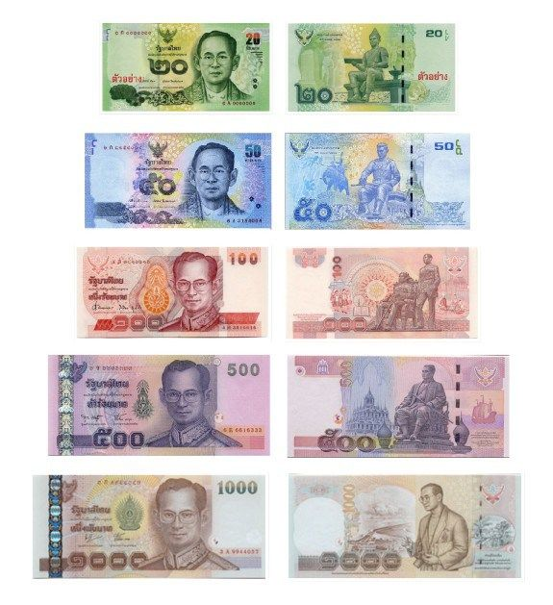

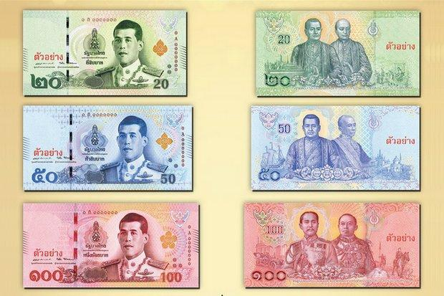

Figure1: Thai Banknotes (King Rama 10) Figure2: Thai Banknotes (King Rama 9)

**References**

<https://www.bot.or.th/Thai/Banknotes/HistoryAndSeriesOfBanknotes/Pages/Evolution_of_Thai_Banknotes.aspx>

<https://theculturetrip.com/asia/thailand/articles/thb-explaining-baht-thailands-currency/>